It’s been a great year so far -
Of course the fantastic show of wildflowers is expected.
However it’s been unusual - lots more Pyramidal Orchids but almost no Spotted/Common. Nothing to worry about, just part of Nature.
Fun-day was a great success too.
We’ve had information stall at Rag and Regatta helping to raise our profile.
There’s a brand new leaflet and pin-badges. Do let us know if you’d like some.
We need to keep working at everything though!

We need HELP – If we don’t recruit now there won’t be anyone to do the work.
Most of us are well over 60 and showing signs of use!
If you can’t get to work-parties how about helping with admin?
Accounts/data protection/Social media
Do please encourage family and friends to join us.

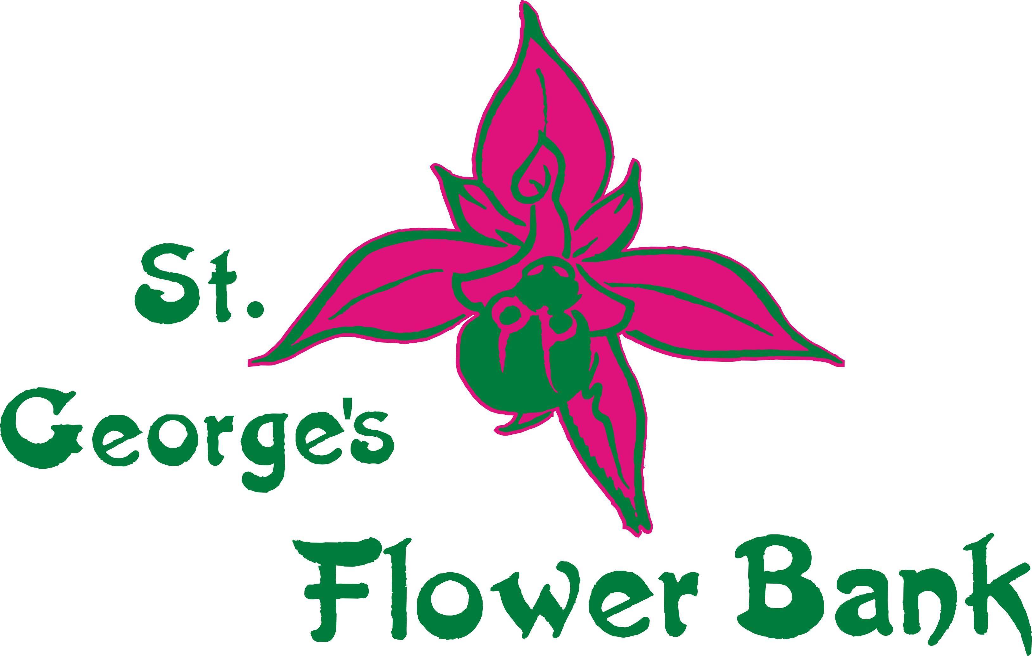 Local Nature Reserve
Newsletter Summer 2019 Page 1

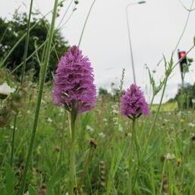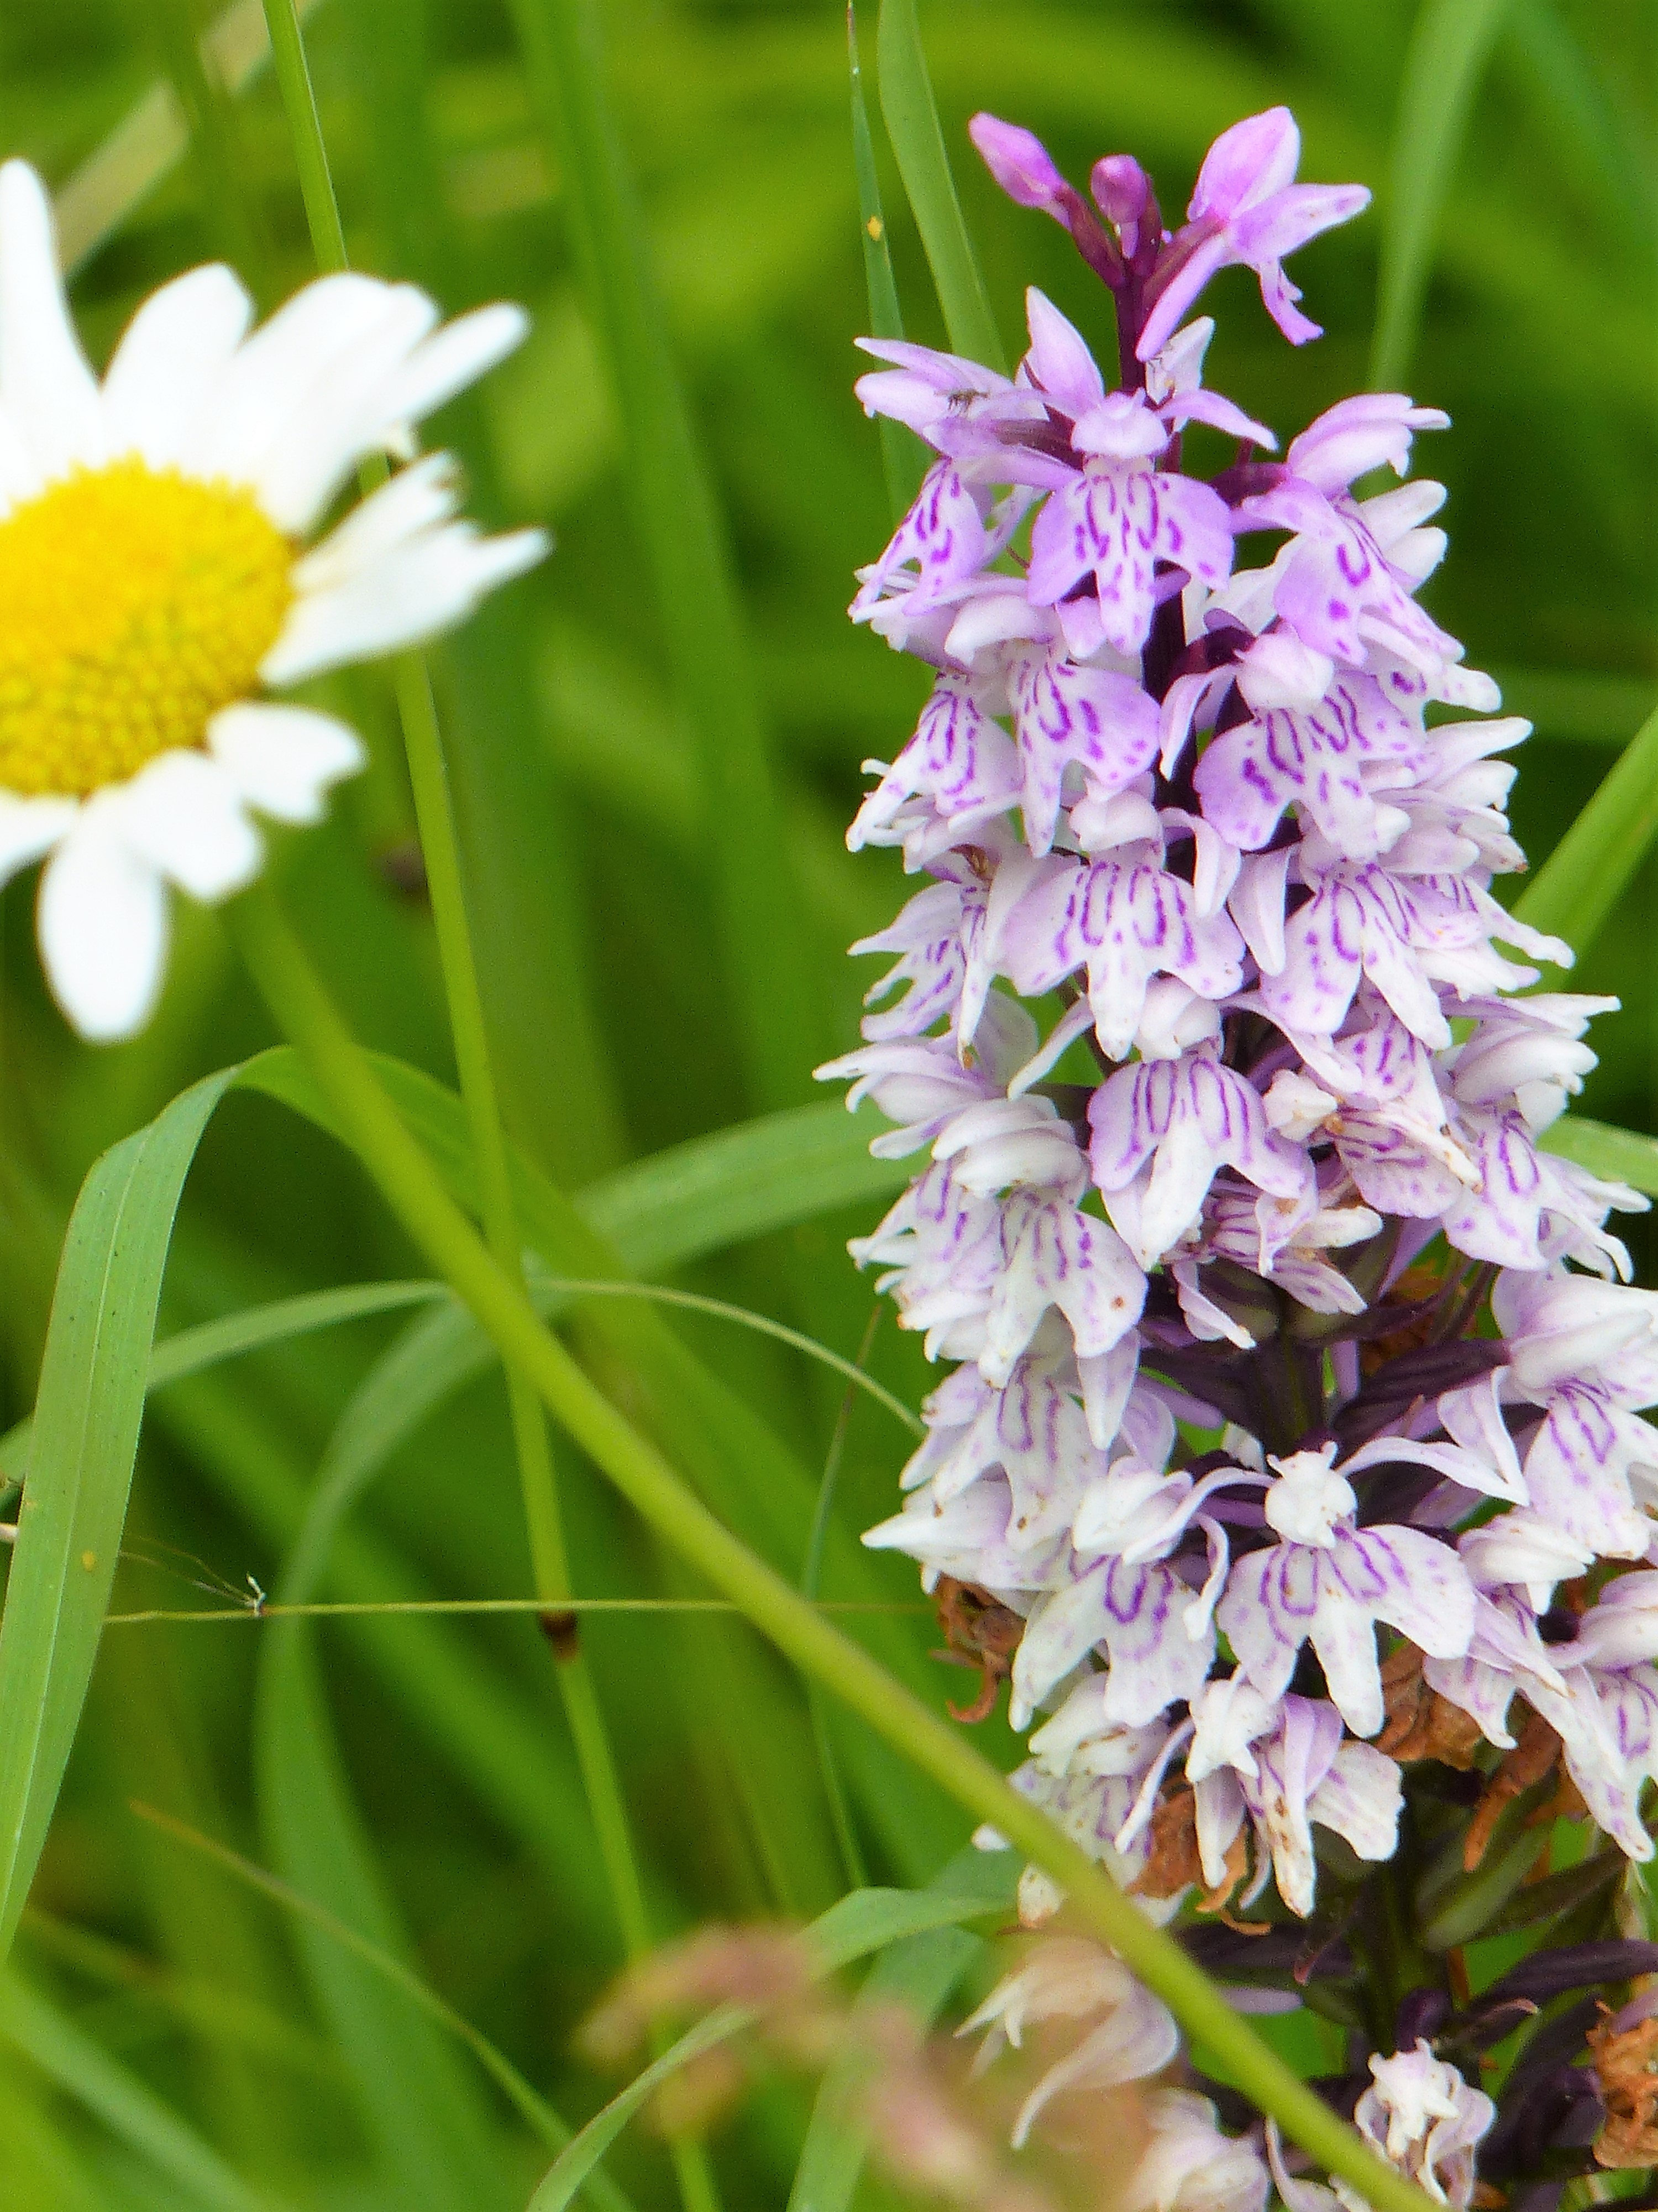
Pyramidal Orchid Marsh/Spotted Orchid

